РУСЕНСКИ УНИВЕРСИТЕТ “АНГЕЛ КЪНЧЕВ”

КУРСОВА РАБОТА
ПО
ПРОГРАМНИ ЕЗИЦИ

Студент:
Фак. Номер:
Група:

ПРОВЕРИЛ:

РУСЕ
2014 г.
- Задание.
Да се разработи на програмния език Java елементарен векторен графичен редактор.
- Графичният редактор да позволява избор на цвят за изчертаване и евентуално на цвят за запълване и да поддържа следните графични примитиви: незапълнен четириъгълник, запълнен четириъгълник и незапълнен овал;
- Изборът на примитив, който ще се въвежда, да става чрез комбо-бокс JComboBox
- Потребителският интерфейс и самите графични примитиви да са разположени в два отделни прозорец;
- По време на работа с редактора обектите от графичните примитиви да се съхраняват в ArrayList. В потребителския интерфейс да се предвиди команда за извеждане на съдържанието му в конзола;
- Да се използва пакетът swing;
- Как се задават примитивите е по избор на студента;
- В програмата може да се използва различни класове по усмотрение на студента, но задължително за всеки графичен примитив трябва да има отделен клас. Всички тези класове трябва да реализират следния интерфейс:
public interface Shape {
public abstract void draw();
}

- Клас диаграма.

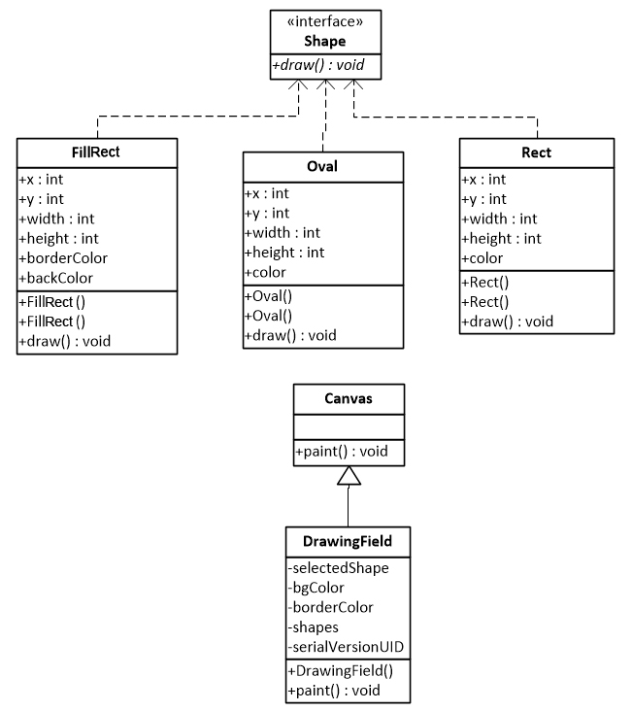
- Листинг.
- Shape.java

import java.awt.Graphics;

public interface Shape{
public abstract void draw(Graphics g);
}
- Rect.java

import java.awt.Color;
import java.awt.Graphics;
import java.awt.Rectangle;

public class Rect implements Shape {

public int x, y, width, height;
public Color color;

public Rect(int x, int y, int width, int height, Color col) {
this.x = x;
this.y = y;
this.width = width;
this.height = height;
this.color = col;
}

public Rect(Rectangle rect, Color col) {
this.x = rect.x;
this.y = rect.y;
this.width = rect.width;
this.height = rect.height;
this.color = col;
}

@Override
public void draw(Graphics g) {
g.setColor(this.color);
g.drawRect(this.x, this.y, this.width, this.height);
}
}
- FillRect.java

import java.awt.Color;
import java.awt.Graphics;
import java.awt.Rectangle;

public class FillRect implements Shape {

public int x, y, width, height;
public Color borderColor;
public Color backColor;

public FillRect(int x, int y, int width, int height, Color background, Color border) {
this.x = x;
this.y = y;
this.width = width;
this.height = height;
this.backColor = background;
this.borderColor = border;
}

public FillRect(Rectangle rect, Color background, Color border) {
this.x = rect.x;
this.y = rect.y;
this.width = rect.width;
this.height = rect.height;
this.backColor = background;
this.borderColor = border;
}

@Override
public void draw(Graphics g) {
g.setColor(this.borderColor);
g.drawRect(this.x, this.y, this.width, this.height);
g.setColor(this.backColor);
g.fillRect(this.x + 1, this.y + 1, this.width - 1, this.height - 1);
}
}
- Oval.java

import java.awt.Color;
import java.awt.Graphics;
import java.awt.Rectangle;

public class Oval implements Shape {

public int x, y, width, height;
public Color color;

public Oval(int x, int y, int width, int height, Color col) {
this.x = x;
this.y = y;
this.width = width;
this.height = height;
this.color = col;
}

public Oval(Rectangle rect, Color col) {
this.x = rect.x;
this.y = rect.y;
this.width = rect.width;
this.height = rect.height;
this.color = col;
}

@Override
public void draw(Graphics g) {
g.setColor(this.color);
g.drawOval(this.x, this.y, this.width, this.height);
}
}

- DrawingField.java

import java.awt.Canvas;
import java.awt.Color;
import java.awt.Graphics;
import java.awt.Rectangle;
import java.awt.event.MouseAdapter;
import java.awt.event.MouseEvent;
import java.util.ArrayList;

public class DrawingField extends Canvas {
private static final long serialVersionUID = 1L;
public byte selectedShape = 0;
public Color bgColor = Color.black, borderColor = Color.black;
public ArrayList<Shape> shapes;

public DrawingField() {
final Rectangle rect = new Rectangle();
shapes = new ArrayList<Shape>();
this.addMouseListener(new MouseAdapter() {
public void mousePressed(MouseEvent e) {
rect.x = e.getX();
rect.y = e.getY();
}

public void mouseReleased(MouseEvent e) {
rect.width = e.getX();
rect.height = e.getY();

if (rect.x <= rect.width && rect.y <= rect.height) {
rect.width -= rect.x;
rect.height -= rect.y;
}
else if (rect.x < rect.width && rect.y > rect.height) {
rect.width -= rect.x;
int oldHeight = rect.height;
rect.height = rect.y - rect.height;
rect.y = oldHeight;
}
else if (rect.x > rect.width && rect.y < rect.height) {
rect.height -= rect.y;
int oldWidtht = rect.width;
rect.width = rect.x - rect.width;
rect.x = oldWidtht;
}
else if (rect.x > rect.width && rect.y > rect.height) {
int oldWidtht = rect.width;
rect.width = rect.x - rect.width;
rect.x = oldWidtht;

int oldHeight = rect.height;
rect.height = rect.y - rect.height;
rect.y = oldHeight;
}

if (selectedShape == 0) {
shapes.add(new Rect(rect, borderColor));
}
else if (selectedShape == 1) {
shapes.add(new FillRect(rect, bgColor, borderColor));
}
else if (selectedShape == 2) {
shapes.add(new Oval(rect, borderColor));
}

repaint();
}
});
}

public void paint(Graphics g) {
for(int i = 0; i < shapes.size(); i++) {
shapes.get(i).draw(g);
}
}
}
- GraphicEditor.java

import java.awt.Color;
import java.awt.event.ActionEvent;
import java.awt.event.ActionListener;
import java.awt.event.ItemEvent;
import java.awt.event.ItemListener;

import javax.swing.JButton;
import javax.swing.JComboBox;
import javax.swing.JFrame;
import javax.swing.JPanel;

public class GraphicEditor {
private JFrame mainFrame, drawFrame;
private JComboBox<String> bgColorList, borderColorList, btnShape;
private JButton btnToConsole;
private DrawingField drawField;
private JPanel toolsPanel;

private GraphicEditor()
{
mainFrame = new JFrame("Векторен графичен редактор");
mainFrame.setLayout(null);
mainFrame.setBounds(0, 0, 400, 110);
mainFrame.setResizable(false);
mainFrame.setDefaultCloseOperation(3);

drawField = new DrawingField();

toolsPanel = new JPanel(null);
toolsPanel.setBounds(5, 5, 380, 115);
mainFrame.add(toolsPanel);

drawFrame = new JFrame("Векторен графичен редактор");
drawFrame.setLayout(null);
drawFrame.setBounds(mainFrame.getBounds().x,
mainFrame.getBounds().y + mainFrame.getBounds().height, 750, 500);
drawFrame.setResizable(false);
drawFrame.setDefaultCloseOperation(0);

drawField.setBounds(5, 5, drawFrame.getBounds().width - 15, drawFrame.getBounds().height - 40);
drawField.setBackground(Color.white);
drawFrame.add(drawField);

btnShape = new JComboBox<String>();
btnShape.setBounds(5, 0, 200, 30);
btnShape.addItem("Незапълнен четириъгълник");
btnShape.addItem("Запълнен четириъгълник");
btnShape.addItem("Незапълнен овал");
btnShape.addItemListener(new ItemListener() {
public void itemStateChanged(ItemEvent e) {
drawField.selectedShape = (byte) btnShape.getSelectedIndex();
}
});
toolsPanel.add(btnShape);

bgColorList = new JComboBox<String>();
bgColorList.setBounds(230, 40, 150, 30);
bgColorList.addItem("Черен");
bgColorList.addItem("Син");
bgColorList.addItem("Зелен");
bgColorList.addItem("Червен");
bgColorList.addItem("Жълт");
bgColorList.addItemListener(new ItemListener() {
public void itemStateChanged(ItemEvent ee) {
String clickedItem = (String) bgColorList.getSelectedItem();
if (clickedItem.equals("Черен")) drawField.bgColor = Color.black;
else if (clickedItem.equals("Син")) drawField.bgColor = Color.blue;
else if (clickedItem.equals("Зелен")) drawField.bgColor = Color.green;
else if (clickedItem.equals("Червен")) drawField.bgColor = Color.red;
else if (clickedItem.equals("Жълт")) drawField.bgColor = Color.yellow;
}
});
toolsPanel.add(bgColorList);

borderColorList = new JComboBox<String>();
borderColorList.setBounds(230, 0, 150, 30);
borderColorList.addItem("Черен");
borderColorList.addItem("Син");
borderColorList.addItem("Зелен");
borderColorList.addItem("Червен");
borderColorList.addItem("Жълт");
borderColorList.addItemListener(new ItemListener() {
public void itemStateChanged(ItemEvent ee) {
String clickedItem = (String) borderColorList.getSelectedItem();
if (clickedItem.equals("Черен")) drawField.borderColor = Color.black;
else if (clickedItem.equals("Син")) drawField.borderColor = Color.blue;
else if (clickedItem.equals("Зелен")) drawField.borderColor = Color.green;
else if (clickedItem.equals("Червен")) drawField.borderColor = Color.red;
else if (clickedItem.equals("Жълт")) drawField.borderColor = Color.yellow;
}
});
toolsPanel.add(borderColorList);

btnToConsole = new JButton("Конзола");
btnToConsole.setBounds(5, 40, 150, 30);
btnToConsole.addActionListener(new ActionListener(){
public void actionPerformed(ActionEvent e) {
System.out.println();
for(int i = 0; i < drawField.shapes.size(); i++) {
System.out.println(drawField.shapes.get(i).getClass().getName());
}
}
});
toolsPanel.add(btnToConsole);

drawFrame.setVisible(true);

mainFrame.setVisible(true);
}

public static void main(String[] args) {
new GraphicEditor();
}
}

